

**Guru Nanak Dev Engineering**

**College, Ludhiana**

Department of Information Technology

**Web Technologies**

Fourth Semester

Session: January – June 2021

Submitted To:

Er. Yadvir Kaur

Department of

Information Technology

(Assistant Professor)

Submitted By:

Kishan Tiwari

D2ITA3

1905354(1921056)

**Name of Practical**

1. **Create a simple web pages by writing HTML using a simple text editor, notepad.**

**Demonstrate the following components of the web page:**

**Page title and headings**

**Paragraph and inline images**

1. **Demonstrate the use of links, lists, and tables in html. You should be able to link separate pages and create named links within a document , using them to build a “table of contents”.**
2. **Create a simple forms in HTML and demonstrate the use of various form elements like input box, textarea, submit and radio buttons etc.**
3. **Demonstrate the use of cascading style sheets(CSS) (inline, internal and external) to specify various aspects of style, such as colours and text fonts and sizes, in html document.**
4. **Creation of web pages using HTML5 and CSS3**
5. **Demonstrate the use of bootstrap framework**
6. **Creating a web page using PHP**
7. **Create a simple web page by writing HTML using a simple text editor, notepad.**

**Demonstrate the following components of the web page**

* **Page tittles and headings**
* **Paragraphs and inline images**

**Code: -**

html>

<head>

<tittle>MY FIRST WEB PAGE</title>

</head>

<body>

<center><h1>GURU NANAK DEV ENGINEERING COLLEGE</H1>

<h3> Department of Information Technology</h3>

<h2>Web Technologies</h2>

<h4>Fourth Semester<br>

Session : January - June 2021</h4>

<img src="file:///C:/Users/10%20PRO%20BOOK/Downloads/logo.jpg"height=200 width=200 hspace=25 border=2 align=center>

<h4 align=left >Submitted To: Er. Yadvir Kaur<br>Department of IT<br>(Assistant Professor)<br><br>

<h4 align=left >Submitted By: Kishan Tiwari<br>D2ITA3<br>1921056(1905354) <br>

</body>

</html>

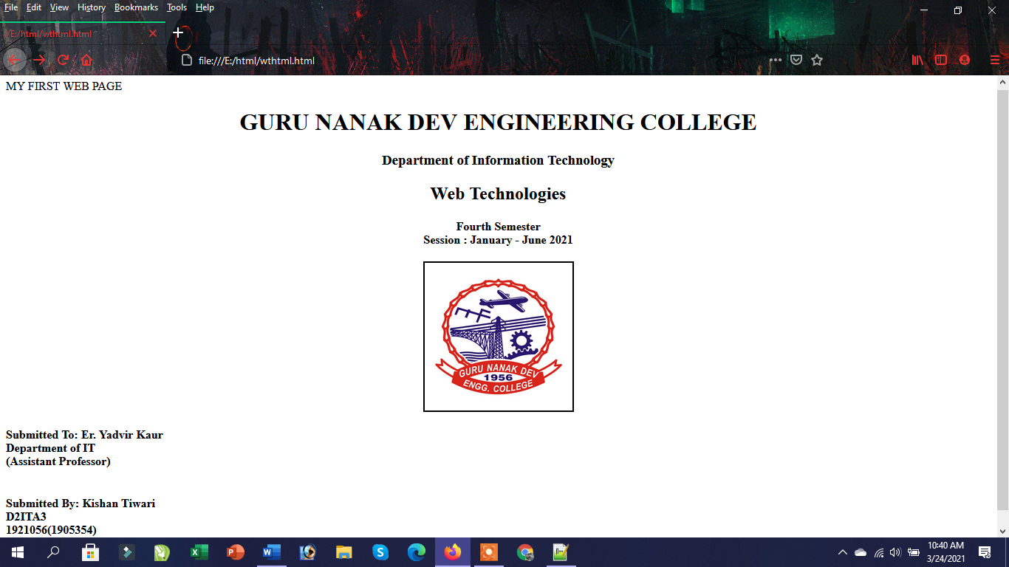

**2. Demonstrate the use of Links, Lists and Tables in HTML. You should be able to link separate pages and create named links within a document, using them to build a “table of contents”.**

**Code:-**

<!DOCTYPE html>

<html>

<head>

<style>

table, th, td {

border: 2px solid black;

}

</style>

</head>

<body>

<center>

<h2><u>Department Wise Information</u></h2></center>

<table style="width:100%">

<tr>

<th>Department</th>

<th>Information about Department</th>

</tr>

<tr>

<td>Coputer Science Department</td>

<td><a href=<a href="https://it.gndec.ac.in/"> CSE</a></td>

</tr>

<tr>

<td>Information Technology</td>

<td><a href="https://it.gndec.ac.in/">It Department</a></td>

</tr>

<tr>

<td>Applied Science</td>

<td><a href="https://appsc.gndec.ac.in/">Applied Science</a></td>

</tr>

</table>

<ol>

<li> <a href="https://cse.gndec.ac.in/?q=node/6">visionofCSE department</a></li>

<li> <a href="https://it.gndec.ac.in/?q=node/6">vision of IT department</a></li>

</ol>

<br>

<ul>

<li> <a href="https://apps.gndec.ac.in/shared/vkD6rZ1UCpn-w4HetTHYiCiHDQiiDvIwSAULAbaGVYs">Notice Board</a></li>

</ol>

</body>

</html>

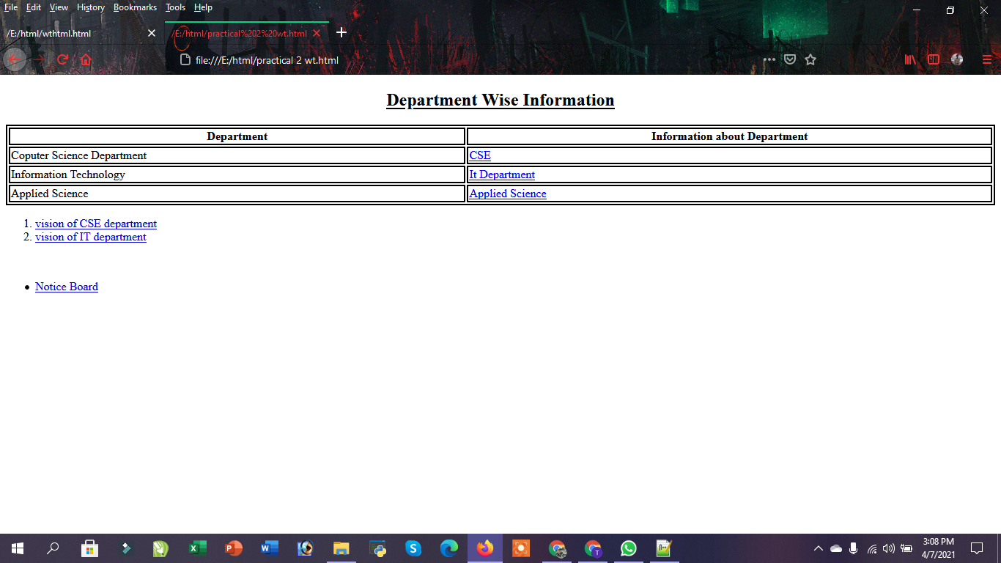

1. **Create simple Forms in HTML and demonstrate the use of various form elements like input box, text area, submit and radio buttons etc.**

**Code :**

<html>

<head>

<title>my 3rd practical wt</title>

</head>

<style>

body{

background : pink;

margin-left:40px;

}

</style>

<body><br><br><br><br>

<center>

<marquee direction ="right" bgcolor="yellow" width= "500px" behaviour = "alternate">

<h1> Registration Form</h1>

</marquee></center>

<form action="/action_page.php" target="_blank" method="get">

<ol><b>

<li>Enter Your Name :<input type="text" value=""> &nbsp &nbsp

<li>Enter Your Father's Name :<input type="text" value=""><br><br>

<li>User name :<input type="text" value=""><br><br>

<li>Hobbies :

<ul>

<li type="square"><input type="radio" value="">dance<br>

<li type="square"><input type="radio" value="">singing

<li type="square"><input type="radio" value="">reading

<li type="square"><input type="radio" value="">cooking

</ul><br><br>

<li> Address :<br>

<textarea rows=5 cols=40> </textarea><br><br>

<li>Select City :

<select>

<option>ludhiana

<option>jalandhar

<option>chandigarh

<option>amritsar

</select><br><br>

<li>Interested Games :

<select size="3">

<option>volleyball

<option>cricket

<option>basketball

<option>handball

<option>badminton

<option>hockey

</select><br><br><br>

<center>

<input type="submit" value="submit">

<input type="reset" value="clear all">

<input type="button" value="next">

</ol>

</form>

</body>

<html>

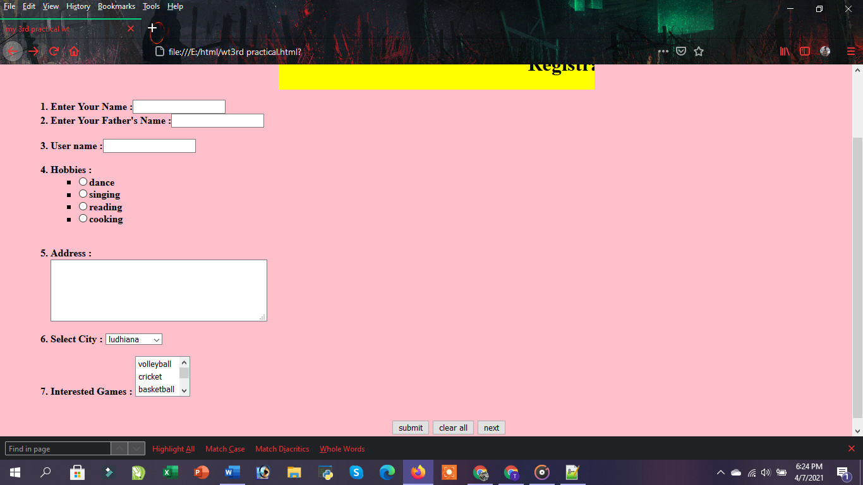

1. **Demonstrate the use of cascading style sheets (CSS) (inline, internal and external) to specify various aspects of style, such as colors and text fonts and sizes, in HTML document.**

**Code :**

1. **Inline Css**

<!DOCTYPE html>

<html>

<head>

<title>inline css</title>

</head>

<body bgcolor=pink>

<center>

<h1 style="font-size:60px;"> Using Inline Css</h1>

<h1 style="background:yellow; color:blue; font-size:50px;">A Blue Heading</h1>

<h2 style="color:red;font-size:40px;">A red paragraph.</p>

</body>

</html>

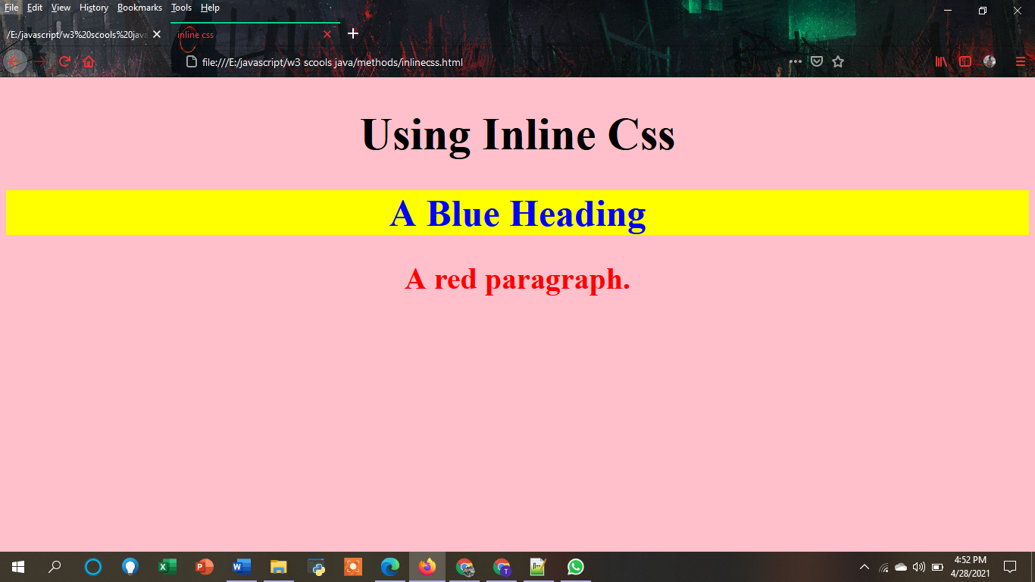

1. **Internal Css**

<!DOCTYP HTML>

<html>

<head>

<title>Internal Css</title>

</head>

<style>

body{

background:pink;

margin-left:1in;

margin-right:1in;

margin-top:60px;

}

h1{

color:red;

background:green;

font-size:40px;

text-align:center;

font-tyle:italic;

font-family:arial;

text-decoration:underline;}

p{

color:blue;

background:yellow;

word-spacing:10px;

font-weight:bold;

text-decoration:underline;

letter-spacing:2px;

line-height:40px;

margin-top:60px;}

</style>

<body>

<h1> Internal Css</h1>

<p>

CSS is the acronym of “Cascading Style Sheets”.

CSS is a computer language for laying out and structuring web pages (HTML or XML).

This language contains coding elements and is composed of these “cascading style sheets” which are equally called CSS files

</p>

</body>

</html>

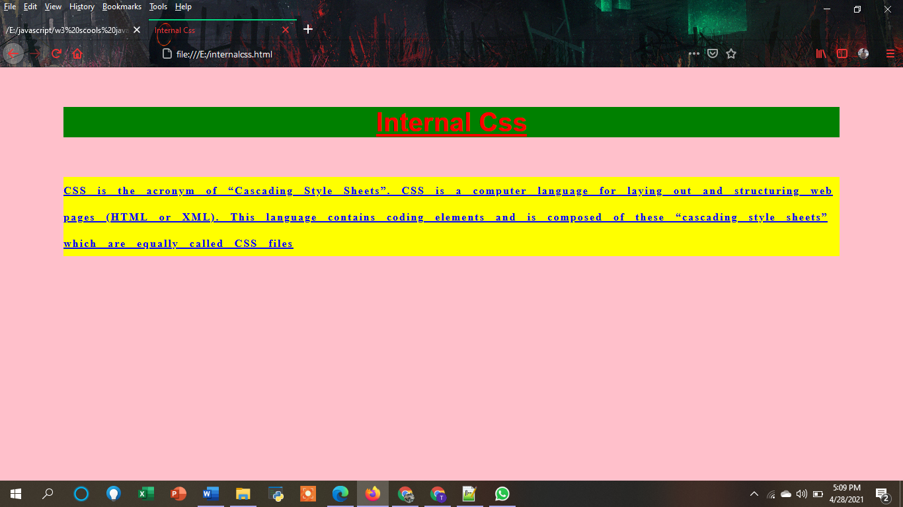

1. **External css**
2. External.css

body{

background:green;

margin-left:1in;

margin-right:1in;

margin-top:60px;

}

h1{

color:blue;

background:red;

font-size:40px;

text-align:center;

font-style:bold;

font-family:arial;

text-decoration:underline;}

p{

color:blue;

background:yellow;

word-spacing:5px;

font-weight:itali;

text-decoration:underline;

letter-spacing:1px;

line-height:40px;

margin-top:60px;}

1. **File:External.html**

<!DOCTYPE htm>

<HTML>

<HEAD>

<TITLE>External Css</title>

</head>

<link rel="stylesheet" href="external.css">

<body>

<h1> External Css</h1>

<p>

External CSS: External CSS contains separate CSS file which contains only style property with the help of tag attributes

(For example class, id, heading, … etc). CSS property written in a separate file with .

css extension and should be linked to the HTML document using link tag.

</p>

</body>

</html>

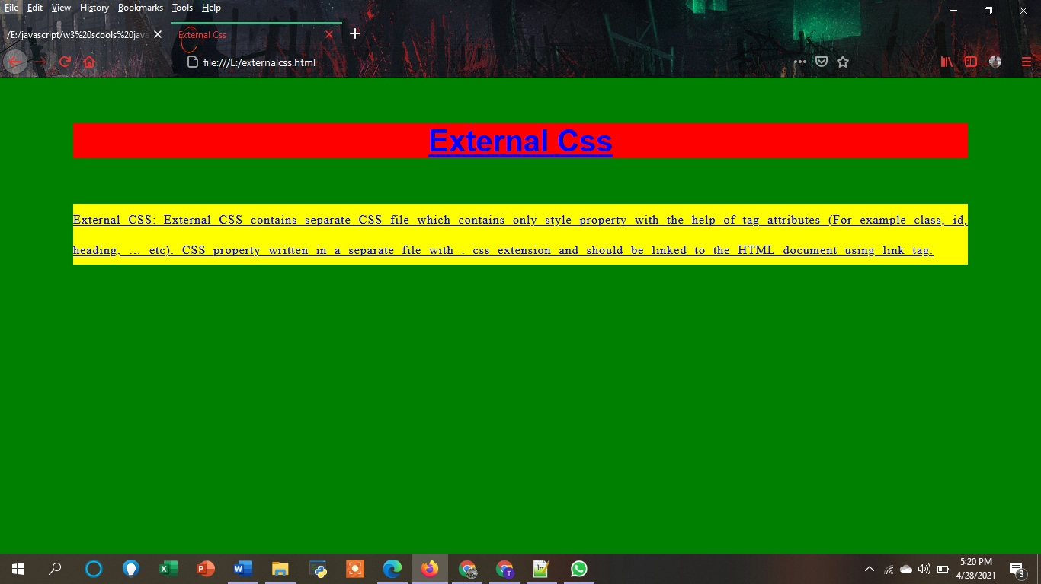

**9. Creation of Web pages using HTML5 and CSS3.**

**Code:-**

* **File code:**

<!DOCTYPE html>

<html lang="en">

<head>

    <meta charset="UTF-8">

    <meta http-equiv="X-UA-Compatible" content="IE=edge">

    <meta name="viewport" content="width=device-width, initial-scale=1.0">

    <title>SOFT TECH</title>

    <link rel="stylesheet" href="css/all.min.css" />

    <link rel="stylesheet" href="css/fontawesome.min.css" />

    <link rel="stylesheet" href="style.css" />

    <link rel="icon" href="images/favico.ico" />

    <link rel="preconnect" href="https://fonts.gstatic.com" />

    <link href="https://fonts.googleapis.com/css2?family=Poppins:wght@300;600;700&display=swap" rel="stylesheet" />

</head>

<body>

    <header>

        <div class="container">

            <nav>

                <h2>SOFT TECH</h2>

                <ul>

                    <li><a href="#" class="active">Home</a></li>

                    <li><a href="#">About</a></li>

                    <li><a href="#">Services</a></li>

                    <li><a href="#">Projects</a></li>

                    <li><a href="#">Conatct</a></li>

                </ul>

            </nav>

        </div>

    </header>

    <!--show case area-->

    <section class="showcase">

        <div class="showcase-content">

            <h1>Buliding Websites and mobile apps for Boostinf your Business</h1>

            <p>

                The asset management tool for developers to collaborate & fix incidents faster. Robust SLAS &

                self-service mgmt. Start a free trial of Jira Service Desk™! Jira® Integration. </p>

            <a href="#" class="btn">Explore </a>

        </div>

    </section>

    <!-- about section-->

    <section class="about m-t">

        <div class="container">

            <h2 class="m-b">About Us</h2>

            <div class="about-wrapper">

                <div class="about-image">

                    <img src="./images/about.jpg" alt="" />

                </div>

                <div class="about-content">

                    <h2>SPECIALISED IN WEBSITE DESIGN AND DEVELOPMENT.</h2>

                    <div class="line"></div>

                    <p>Web design refers to the design of websites that are displayed on the internet. It usually refers

                        to the user experience aspects of website development rather than software development. ... A

                        web designer works on the appearance, layout, and, in some cases, content of a website.

                    </p>

                    <ul class="fa-ul">

                        <li>

                            <span class="fa-li"><i class="fas fa-circle-notch"></i></span>

                            Proving you solution for all of your software needs

                        </li>

                        <li>

                            <span class="fa-li"><i class="fas fa-circle-notch"></i></span>

                            mobile app developmnt

                        </li>

                        <li>

                            <span class="fa-li"><i class="fas fa-circle-notch"></i></span>

                            wordpress development made easy

                        </li>

                    </ul>

                    <div class="social-icon">

                        <a href="#"><i class="fab fa-facebook-f"></i></a>

                        <a href="#"><i class="fab fa-twitter"></i></a>

                        <a href="#"><i class="fab fa-youtube"></i></a>

                        <a href="#"><i class="fab fa-linkedin-in"></i></a>

                    </div>

                </div>

            </div>

        </div>

    </section>

</body>

</html>

* **CSS FILE:-**

*{

    margin:0;

    padding:0;

    box-sizing: border-box;

}

body{

    font-family:"poppins",sans-serif;

}

:root{

    --el-color:#333;

}

h1,h2,h3,h4,a,p{

    color:var(--el-color);

}

a{

    text-decoration:none;

}

h1{

    font-size: 2.5rem;

}

h2{

    font-size: 2rem;

    text-transform: uppercase;

    font-weight: 600;

    letter-spacing: 2px;

}

h3{

    font-weight: 600;

}

i{

    color:#eb7620;

}

p{

    font-weight: 300;

}

.m-t{

    margin-top: 150px;

}

.m-b{

    margin-bottom: 100px;

}

.container{

    width:70%;

    margin: auto;

    text-align: center;

}

/*header section*/

nav{

    height: 100px;

}

nav h2{

    float:left;

    line-height: 100px;

    display: inline;

}

nav ul{

    float: right;

    line-height: 100px;

}

nav ul li{

    display: inline-block;

    margin: 0 25px;

}

nav ul li a{

    text-transform: uppercase;

}

.active{

    background-color: #eb7620;

    border-radius: 20px;

    padding: 7px 25px;

    color:#fff;

}

/* show case area */

.showcase {

    height: calc(100vh - 100px);

    background-image:linear-gradient(rgba(0,0,0,0.5),rgba(0,0,0,0.5)), url("images/background.jpg");

    background-size: cover;

    background-repeat: no-repeat;

    border-bottom: 10px solid #eb7620;

}

.showcase-content h1{

    color:#fff;

    letter-spacing:2px;

}

.showcase-content p{

    color:#fff;

    margin: 50px 0 ;

}

.showcase-content{

    width:50%;

    margin: auto;

    text-align: center ;

    transform: translateY(30vh);

}

.showcase-content .btn {

    color:#fff;

    border: 2px solid #fff;

    padding:10px 60px;

    font-weight: 600;

    letter-spacing: 2px;

    text-transform: uppercase;

    transition: 0.5% all;

}

.showcase-content .btn:hover{

    background-color: #eb7620;

    border:0;

}

/* About*/

.about .about-image{

    width: 45%;

    float: left;

}

.about-wrapper img{

    max-width:100%;

    height:auto;

}

.about .about-content{

    width:45%;

    float:right;

    text-align:left;

    margin-top: 60px;

}

.about .line{

    width:150px;

    height:6px;

    margin-top: 50px;

    background-color: #333;

}

.about p{

    margin-top: 50px;

}

.about ul{

    margin-top: 50px;

    list-style :none;

}

.about ul li{

    margin-top: 10px 0;

}

.about .fa-li{

    margin-left: -20px;

}

.social-icon{

    margin-top: 50px;

}

.social-icon i{

    padding: 10px;

    font-size:30px;

    border:1px solid black;

}

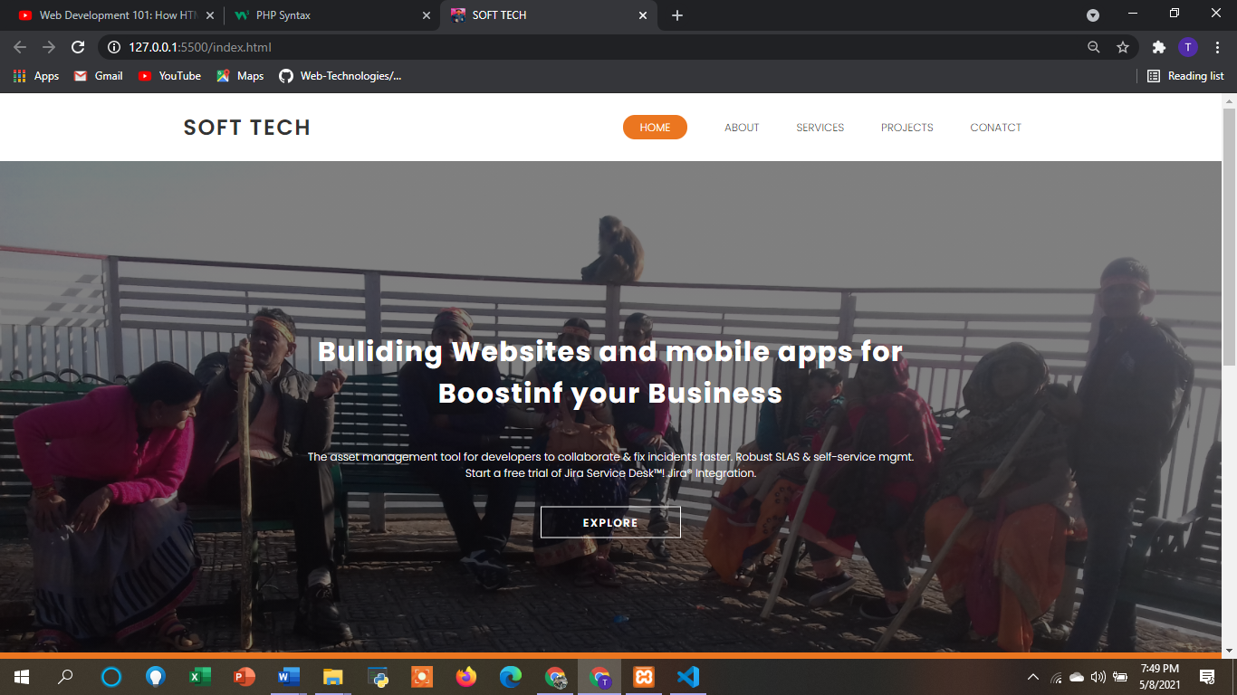

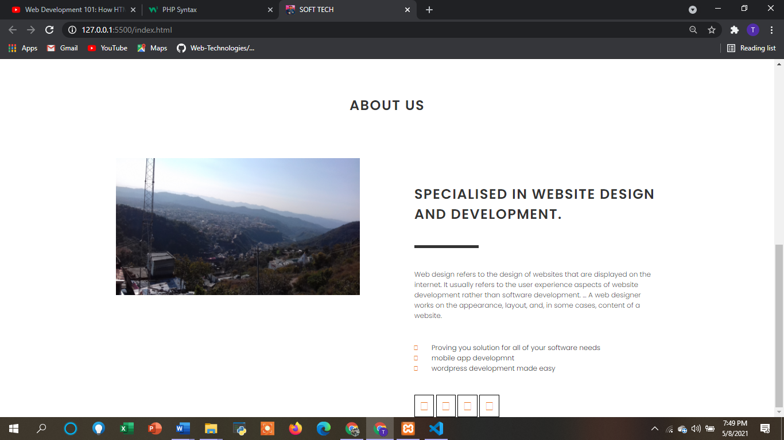

**10. Demonstrate the use of Bootstrap Framework.**

**Code:**

* **Html File:**

<html>

<head>

    <title>

        How to make website.

    </title>

<link rel="stylesheet" href="style.css">

    <link rel="stylesheet" href="https://maxcdn.bootstrapcdn.com/bootstrap/3.4.1/css/bootstrap.min.css">

    <!-- jQuery library -->

    <script src="https://ajax.googleapis.com/ajax/libs/jquery/3.5.1/jquery.min.js"></script>

    <!-- Latest compiled JavaScript -->

    <script src="https://maxcdn.bootstrapcdn.com/bootstrap/3.4.1/js/bootstrap.min.js"></script>

</head>

<body>

<header class="header">

    <nav class="navbar navbar-style">

        <div class="container">

            <div class="navbar-header">

                <button type="button" class="navbar-toggle" data-toggle="collapse" data-target="#micon">

                    <span class="icon-bar"></span>

                    <span class="icon-bar"></span>

                    <span class="icon-bar"></span>

                </button>

                <a href=""><img class="logo" src="logo.png"></a>

            </div>

        <div class="collapse navbar-collapse" id="micon">

            <ul class="nav navbar-nav navbar-right">

                <li><a href="">Home</a></li>

                <li><a href="">Features</a></li>

                <li><a href="">Team</a></li>

                <li><a href="">Gallery</a></li>

                <li><a href="">Contact Us</a></li>

            </ul>

        </div>

    </nav>

    <div class="container">

        <div class="row">

            <div class="col-sm-6 banner-info">

                <h1>How To</h1>

                <p class="big-text"> Create Responsive Website </p>

                <p>Learn How To Make Responsive Website Using HTML, CSS And Bootstrap </p>

                <a class="btn btn-first" href="#"> like video </a>

                <a class="btn btn-second" href="#">Subscribe Us </a>

            </div>

            <div class="col-sm-6 banner-image">

                <img src="image.jpg" class="img-responsive">

            </div>

        </div>

    </div>

</header>

</body>

</html>

* **Css File:**

*{

    margin:0;

    padding: 0;

}

.header{

    height: 100vh;

}

.navbar-style{

    box-shadow: 0 5px 10px #efefef;

    text-transform: uppercase;

}

.logo{

    height: 48px;

    padding: 2px 10px ;

}

.icon-bar{

    background: darkorange;

}

li a{

    color: #333;

}

.big-text

{

    font-size: 52px;

    margin: 20px 0;

    color: darkorange;

}

a.btn{

    margin: 30px 10px ;

    width: 150px;

    padding: 10px;

    border-radius: 20px ;

}

a.btn-first{

    background-color: darkorange;

    color: #fff;

}

a.btn-second {

   background: transparent;

   border:1px solid darkorange;

   color: #333;

}

a.btn:hover{

    background: darkorange;

    border: none;

    color: #fff;

    box-shadow: 5px 5px 10px #999;

    transition:0.3s;

}

.banner-info, .banner-image {

    margin: 30px 0 ;

}

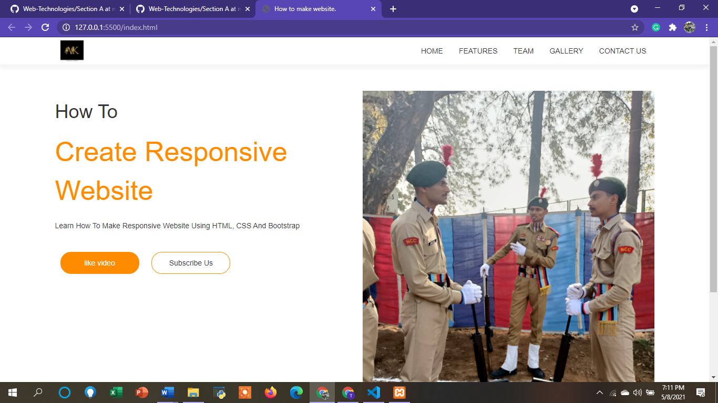

**12. Creating web pages using PHP.**

**Code:**

* **Html File:**

<!DOCTYPE html>

<html lang="en">

<head>

    <meta charset="UTF-8">

    <meta http-equiv="X-UA-Compatible" content="IE=edge">

    <meta name="viewport" content="width=device-width, initial-scale=1.0">

    <title>SOFT TECH</title>

    <link rel="stylesheet" href="css/all.min.css" />

    <link rel="stylesheet" href="css/fontawesome.min.css" />

    <link rel="stylesheet" href="styling.css" />

    <link rel="icon" href="images/favico.ico" />

    <link rel="preconnect" href="https://fonts.gstatic.com" />

    <link href="https://fonts.googleapis.com/css2?family=Poppins:wght@300;600;700&display=swap" rel="stylesheet" />

</head>

<body>

    <header>

        <div class="container">

            <nav>

                <h2>KISHANKU</h2>

                <ul>

                    <li><a href="#" class="active">Home</a></li>

                    <li><a href="#">About</a></li>

                    <li><a href="#">Products</a></li>

                    <li><a href="#">Coustomers</a></li>

                    <li><a href="#">Conatct Us</a></li>

                </ul>

            </nav>

        </div>

    </header>

    <!--show case area-->

    <section class="showcase">

        <div class="showcase-content">

            <u><h1>The Standard For Influencer Marketing</h1></u>

            <p>

                Tracker provides influencer discovery ,vetting relationship management ,campaign organisation,measurement

                ,and the industry's only influencer market performance benchmark  </p>

            <a href="#" class="btn">Explore </a>

        </div>

    </section>

    <!-- about section-->

    <section class="about m-t">

        <div class="container">

            <h2 class="m-b">About Us</h2>

            <div class="about-wrapper">

                <div class="about-image">

                    <img src="logo.png" alt="" />

                </div>

                <div class="about-content">

                    <h2>SPECIALISED IN WEBSITE DESIGN AND DEVELOPMENT.</h2>

      <div class="line"></div>

                    <p>Web design refers to the design of websites that are displayed on the internet. It usually refers

                        to the user experience aspects of website development rather than software development. ... A

                        web designer works on the appearance, layout, and, in some cases, content of a website.

                    </p>

                    <ul class="fa-ul">

                        <li>

                            <span class="fa-li"><i class="fas fa-circle-notch"></i></span>

                            Proving you solution for all of your software needs

                        </li>

                        <li>

                            <span class="fa-li"><i class="fas fa-circle-notch"></i></span>

                            mobile app developmnt

                        </li>

                        <li>

                            <span class="fa-li"><i class="fas fa-circle-notch"></i></span>

                            wordpress development made easy

                        </li>

                    </ul>

                    <div class="social-icon">

                        <a href="#"><i class="fab fa-facebook-f"></i></a>

                        <a href="#"><i class="fab fa-twitter"></i></a>

                        <a href="#"><i class="fab fa-youtube"></i></a>

                        <a href="#"><i class="fab fa-linkedin-in"></i></a>

                    </div>

                </div>

            </div>

        </div>

    </section>

</body>

</html>

* **Css File:**

*{

    margin:0;

    padding:0;

    box-sizing: border-box;

}

body{

    font-family:"poppins",sans-serif;

}

:root{

    --el-color:#333;

}

.logo{

    height: 70px;

    padding: 5px 10px ;

}

h1,h2,h3,h4,a,p{

    color:grey;

}

a{

    text-decoration:none;

}

h1{

    font-size: 2.5rem;

}

h2{

    font-size: 2rem;

    text-transform: uppercase;

    font-weight: 600;

    letter-spacing: 2px;

}

h3{

    font-weight: 600;

}

i{

    color:#eb7620;

}

p{

    font-weight: 300;

}

.m-t{

    margin-top: 150px;

}

.m-b{

    margin-bottom: 100px;

}

.container{

    width:70%;

    margin: auto;

    text-align: center;

}

/*header section*/

nav{

    height: 100px;

}

nav h2{

    float:left;

    line-height: 100px;

    display: inline;

}

nav ul{

    float: right;

    line-height: 100px;

}

nav ul li{

    display: inline-block;

    margin: 0 25px;

}

nav ul li a{

    text-transform: uppercase;

}

.active{

    background-color: #eb7620;

    border-radius: 20px;

    padding: 7px 25px;

    color:#fff;

}

/* show case area */

.showcase {

    height: calc(100vh - 100px);

    background-image:linear-gradient(rgba(0,0,0,0.5),rgba(0,0,0,0.5)), url("1.png");

    background-size: cover;

    background-repeat: no-repeat;

    border-bottom: 10px solid #eb7620;

}

.showcase-content h1{

    color:whitesmoke;

    letter-spacing:2px;

}

.showcase-content p{

    color:white;

    margin: 50px 0 ;

}

.showcase-content{

    width:50%;

    margin: auto;

    text-align: center ;

    transform: translateY(30vh);

}

.showcase-content .btn {

    color:#fff;

    border: 2px solid #fff;

    padding:10px 60px;

    font-weight: 600;

    letter-spacing: 2px;

    text-transform: uppercase;

    transition: 0.5% all;

}

.showcase-content .btn:hover{

    background-color: yellowgreen;

    border:0;

}

/* About*/

.about .about-image{

    width: 45%;

    float: left;

}

.about-wrapper img{

    max-width:100%;

    height:auto;

}

.about .about-content{

    width:45%;

    float:right;

    text-align:left;

    margin-top: 60px;

}

.about .line{

    width:150px;

    height:6px;

    margin-top: 50px;

    background-color: #333;

}

.about p{

    margin-top: 50px;

}

.about ul{

    margin-top: 50px;

    list-style :none;

}

.about ul li{

    margin-top: 10px 0;

}

.about .fa-li{

    margin-left: -20px;

}

.social-icon{

    margin-top: 50px;

}

.social-icon i{

    padding: 10px;

    font-size:30px;

    border:1px solid black;

}

